**ENGG100 Quiz 2 Practice Questions**

1. Write the MATLAB code to display Age: 19

|  |
| --- |
| Answer: |

1. Which of the following will obtain [1 4 9 16]?
   1. t = [1 2 3 4]; t^2
   2. t = [1 2 3 4]; t.^2
   3. t = [1 2 3 4]^2
   4. all of them

|  |
| --- |
| Answer: |

1. Which of the following can create a time array from 0s to 5s with increments of 0.02s?
   1. t = 0:5:0.02
   2. t = 5:0:0.02
   3. t = 0:0.02:5
   4. none of them

|  |
| --- |
| Answer: |

1. Write the MATLAB code to create the matrix A below and then change the value of A(2,3) to -9

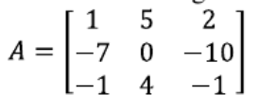

|  |
| --- |
| Answer: |

1. What are the correct statements for “clear” and “clc” MATLAB functions?
   1. “clear” cleans the command window and “clc” is shortcut
   2. “clear” cleans the command window history and “clc” is shortcut
   3. “clear” cleans workspace and “clc” cleans command window
   4. “clear” cleans the command window and “clc” cleans the workspace

|  |
| --- |
| Answer: |

1. What is the common data type for numeric values in MATLAB?
   1. int
   2. char
   3. array
   4. double

|  |
| --- |
| Answer: |

1. What is the size of the array = [3 6 7 3; 4 5 7 8; 1 4 6 4]?

|  |
| --- |
| Answer: |

1. What would be the result of this code: disp(‘I will score’, 100, ‘in this subject’);

|  |
| --- |
| Answer: |

1. Write a MATLAB script to create an array below:

|  |  |  |  |
| --- | --- | --- | --- |
| Name | Subject | Marks | Attendance |
| Jimmy | ENGG100 | 89 | A |
| Carl | ENGG102 | 78 | P |
| Rose | ENGG103 | 90 | P |

Once the array is created, write the code to change the below:

1. Change Carl’s name to James
2. Update Rose’s marks to 77
3. Change Jimmy’s attendance to P

|  |
| --- |
| Answer: |

1. Write a script to calculate the factorial of a number input by the user. A factorial is a number multiplied with all the numbers below it. E.g. the factorial of 7 would be 7x6x5x4x3x2x1. Hint: Use a for loop for this.

|  |
| --- |
| Answer: |

1. Explain what is wrong with the following MATLAB code:

% This code assigns a value of x to zeroValue only if x is equal to zero

x = 4;

if x = 0

zeroValue = x;

end

|  |
| --- |
| Answer: |

1. Write a MATLAB script to generate 20 times a random number between 1 and 100 and count how many times out of the 20 times an even number is generated.

|  |
| --- |
| Answer: |

1. Convert the below flowchart into MATLAB code using conditional statements. Make sure your code recognizes string values “Yes” and “No” entered by the user.

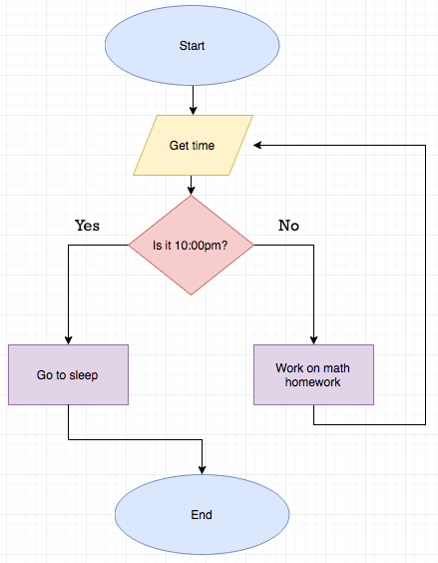

|  |
| --- |
| Answer: |

1. What would be the final output of this code (in the command window)?

a = 6;

b = 7;

if a >= 5 || b <= 7

disp(‘This is the first condition);

else

disp(‘This is the second condition’);

end

|  |
| --- |
| Answer: |

1. Consider theta = pi/6, m’ = 4, n’ = 2, write a MATLAB script to calculate the value for [m;n]

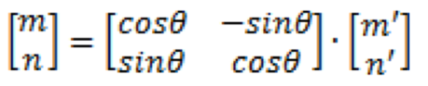

|  |
| --- |
| Answer: |